DSD ASSIGNMENT

VERILOG HDL

GATE LEVEL MODELLING, DATA FLOW LEVEL MODELLING, BEHAVIOURAL MODELLING

**BY – AAYUSH ARORA**

**EE17BTECH11003**

**XOR GATE:-**

The XOR gate is a digital logic gate that gives a true (1/HIGH) output when the number of true inputs are odd.

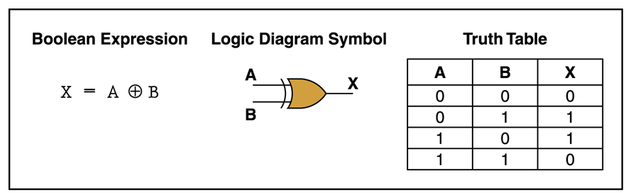

* **DATA FLOW MODEL**

**PROGRAM CODE**

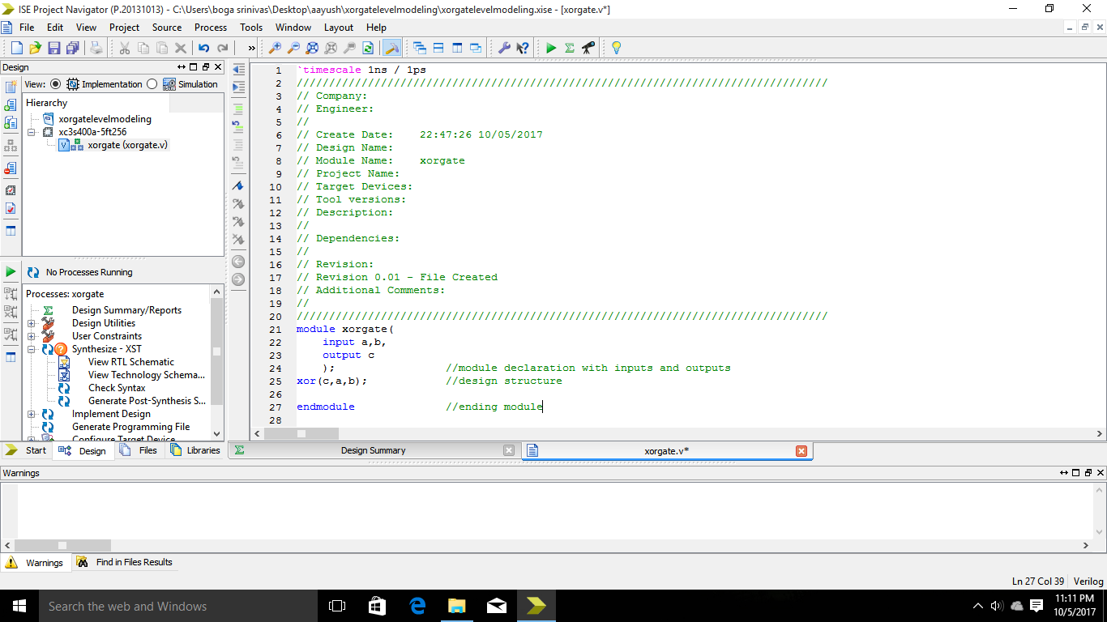 **NETS-**

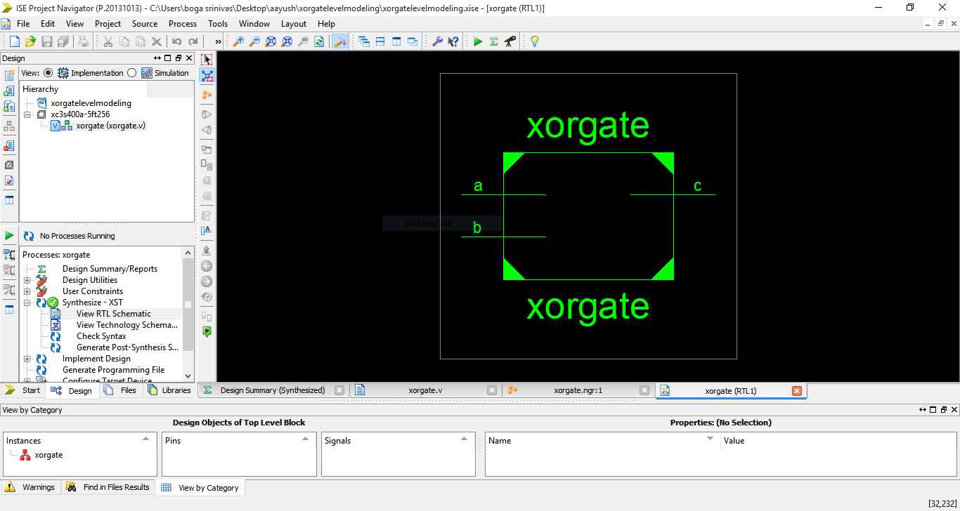

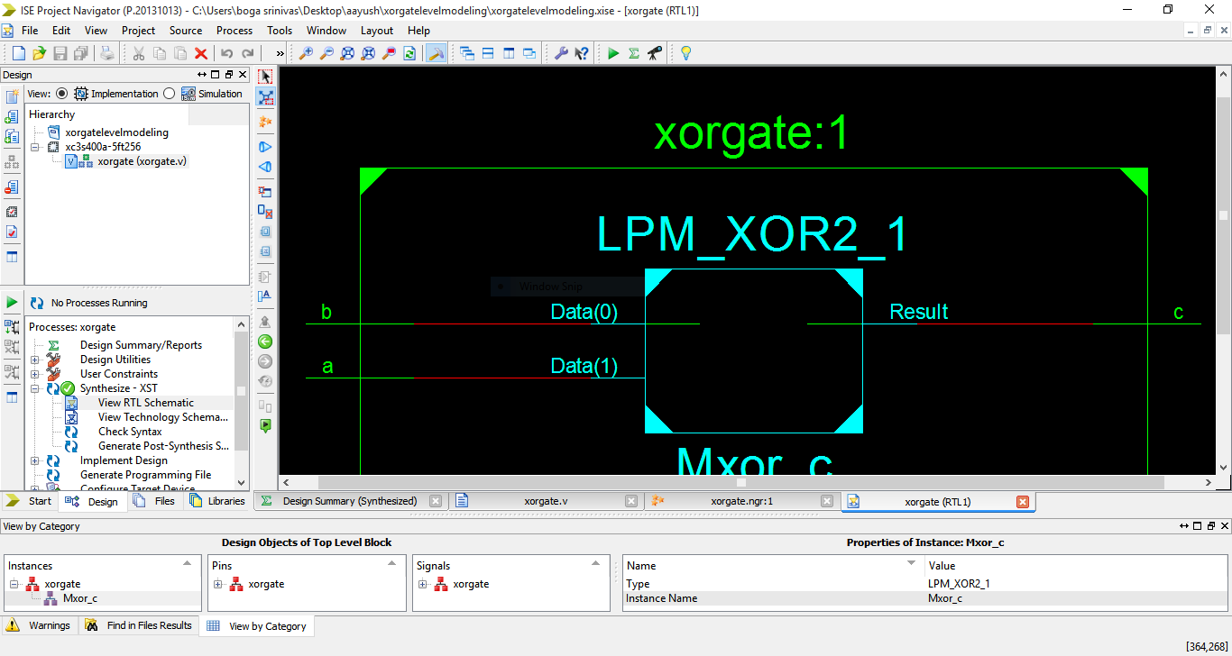

STIMULUS-

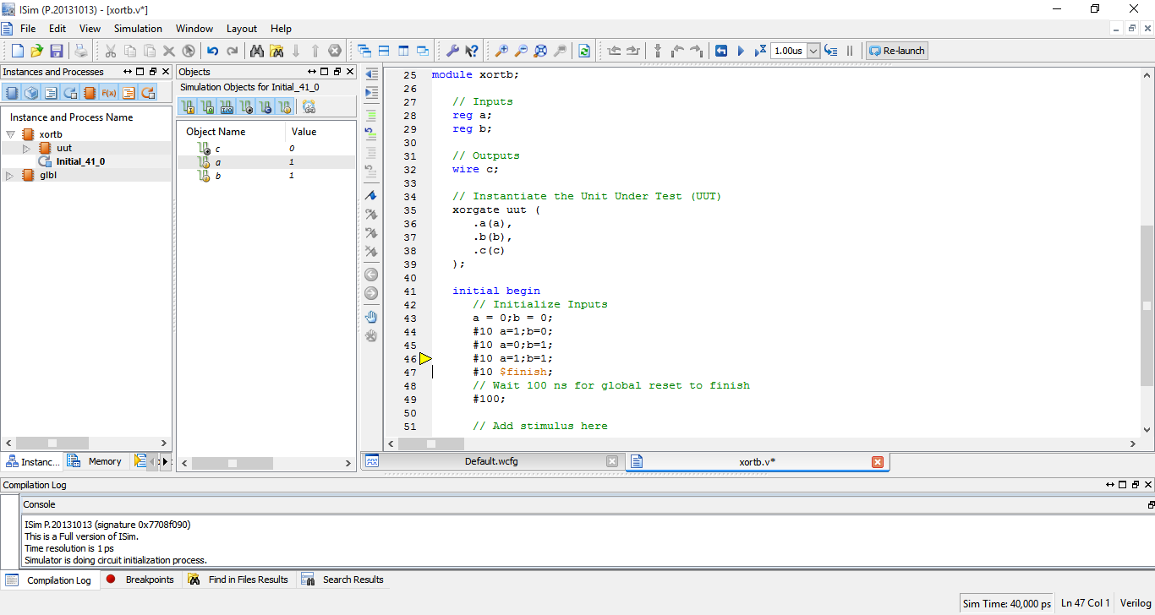

WAVE FORM-

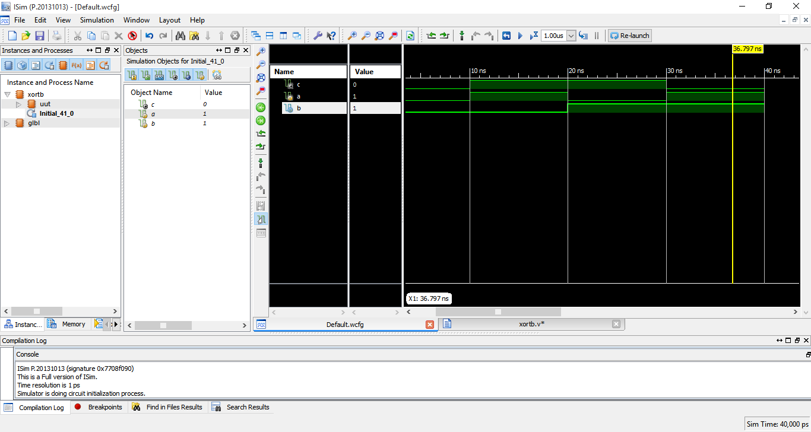

* **DATA FLOW MODEL**

**PROGRAM CODE**

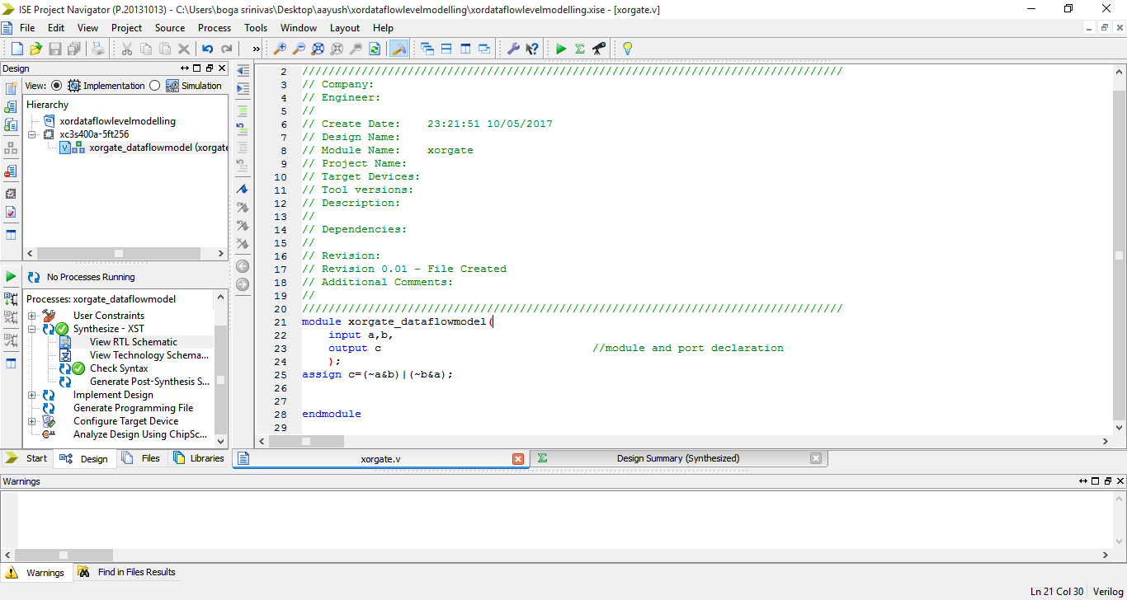

**NETS**

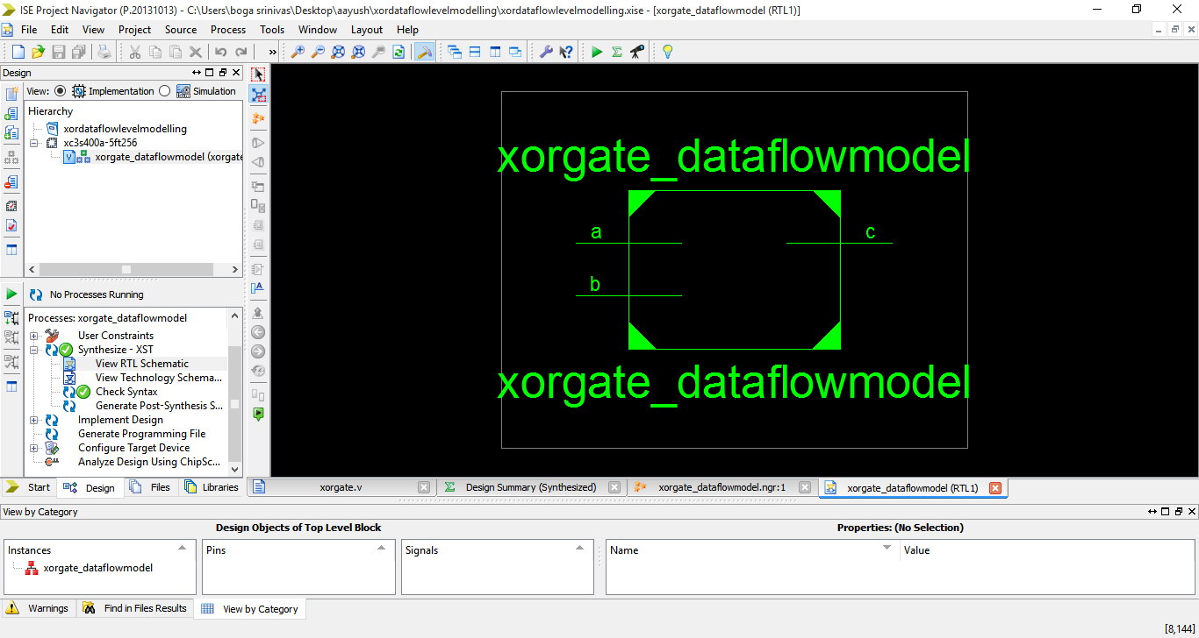

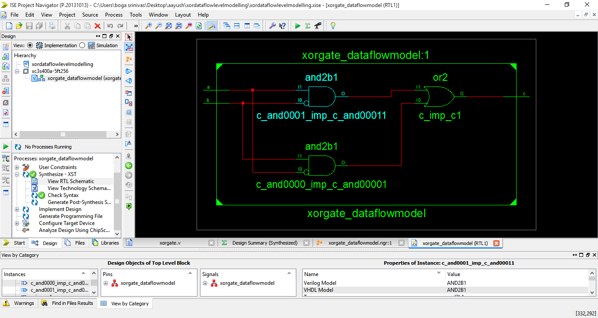

**STIMULUS**

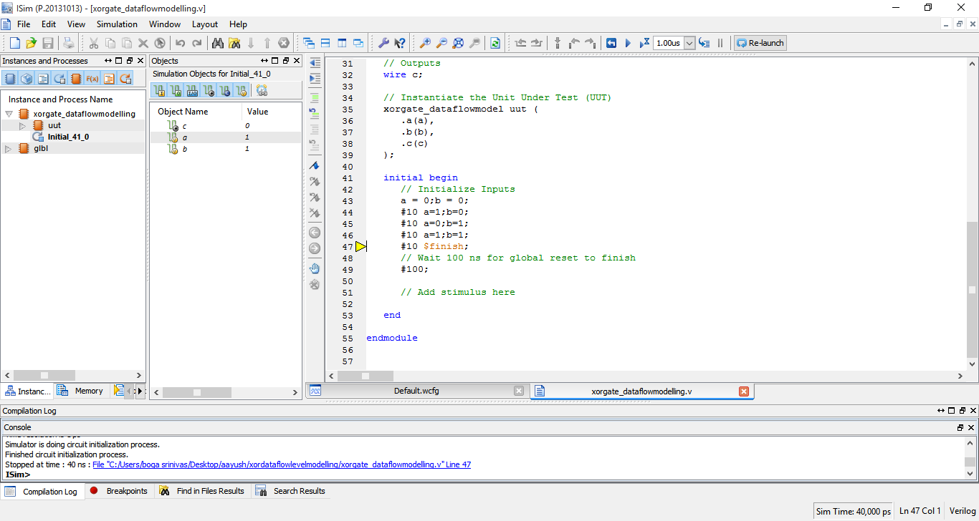

**WAVE FORM**

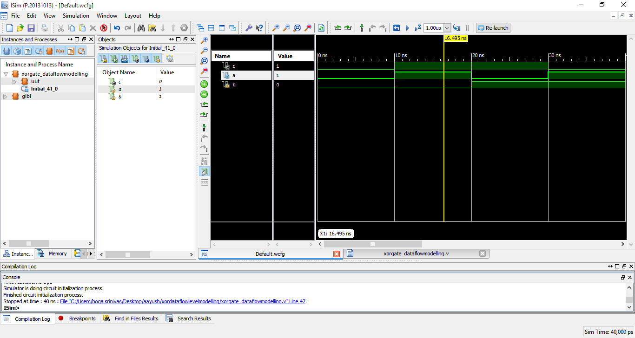

* **BEHAVIOURAL MODEL**

**PROGRAM CODE**

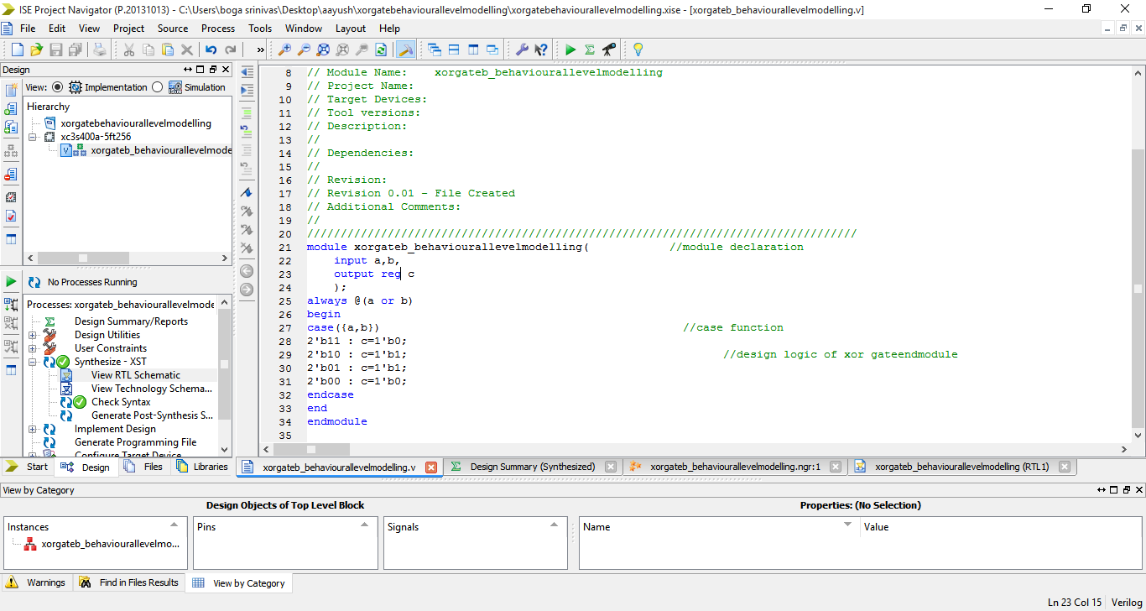

**NETS**

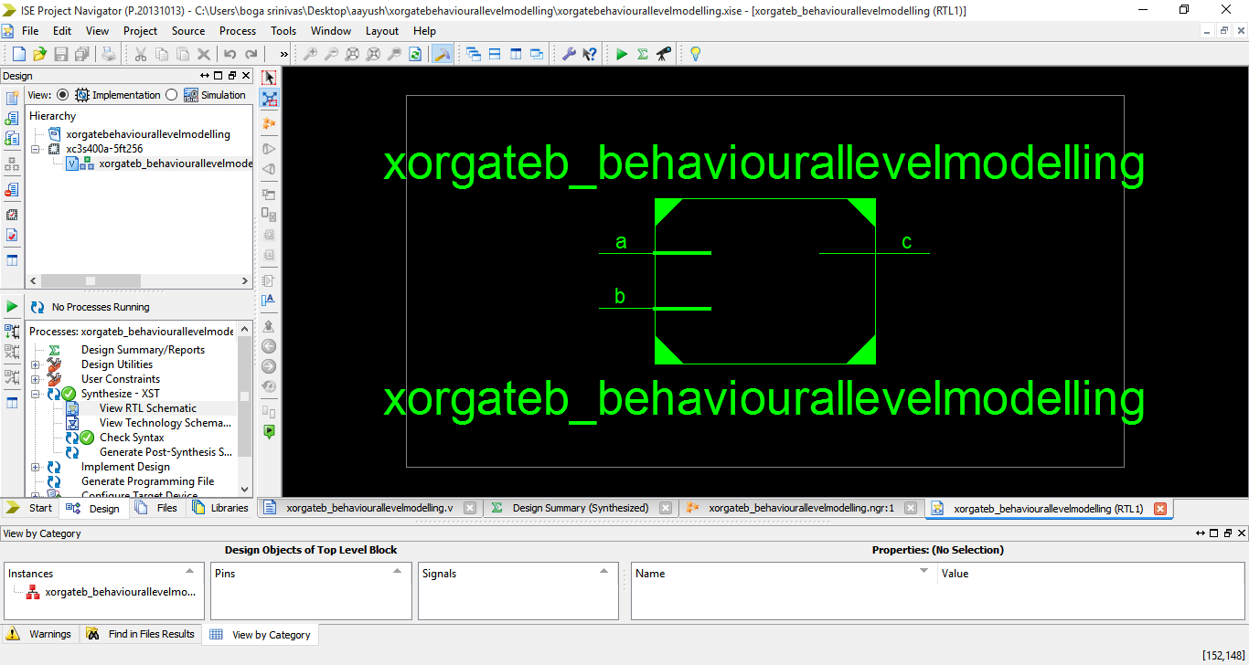

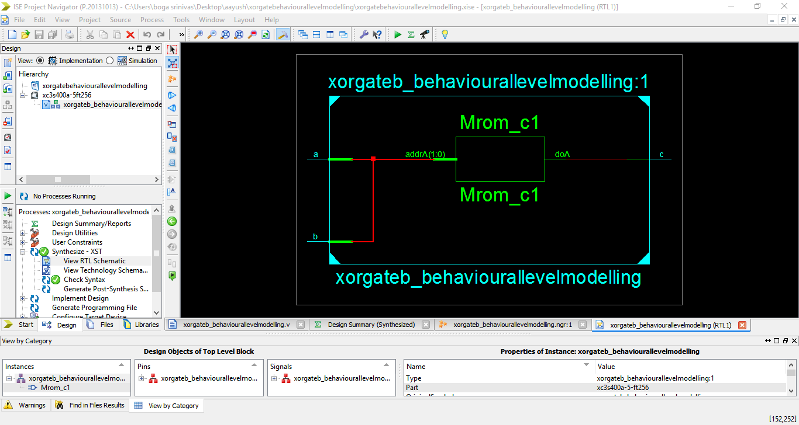

**STIMULUS**

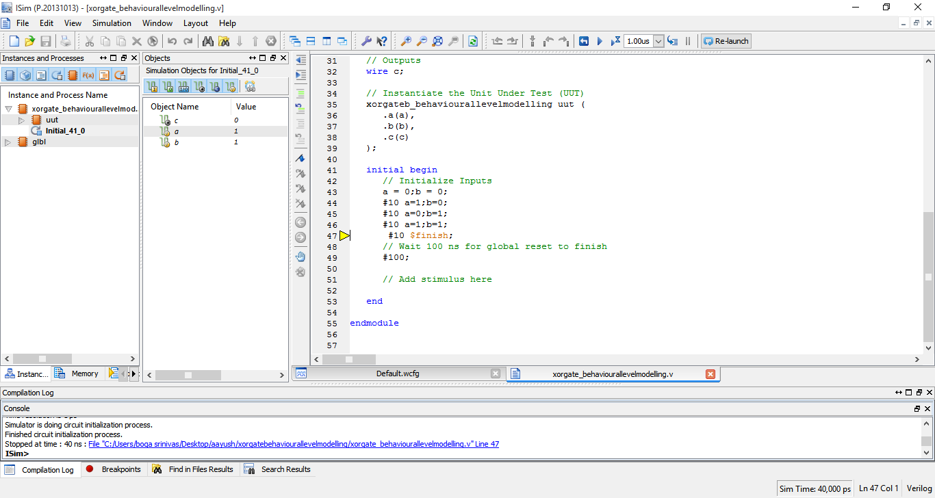

**WAVE FORM**

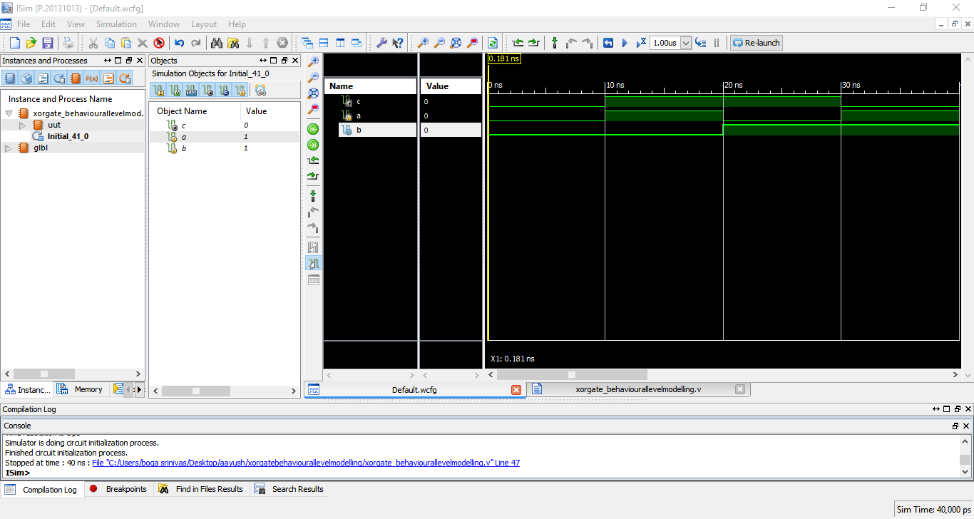

FULL ADDER:-

A full adder is a combinational circuit that adds two bits taking in account the carry input and giving sum of two numbers along with carry output for further manipulation.

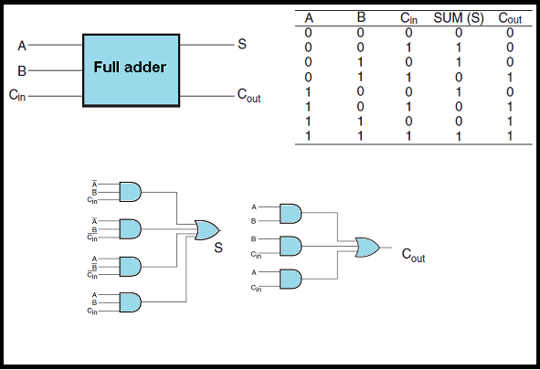

* **GATE LEVEL MODEL**

**PROGRAM CODE**

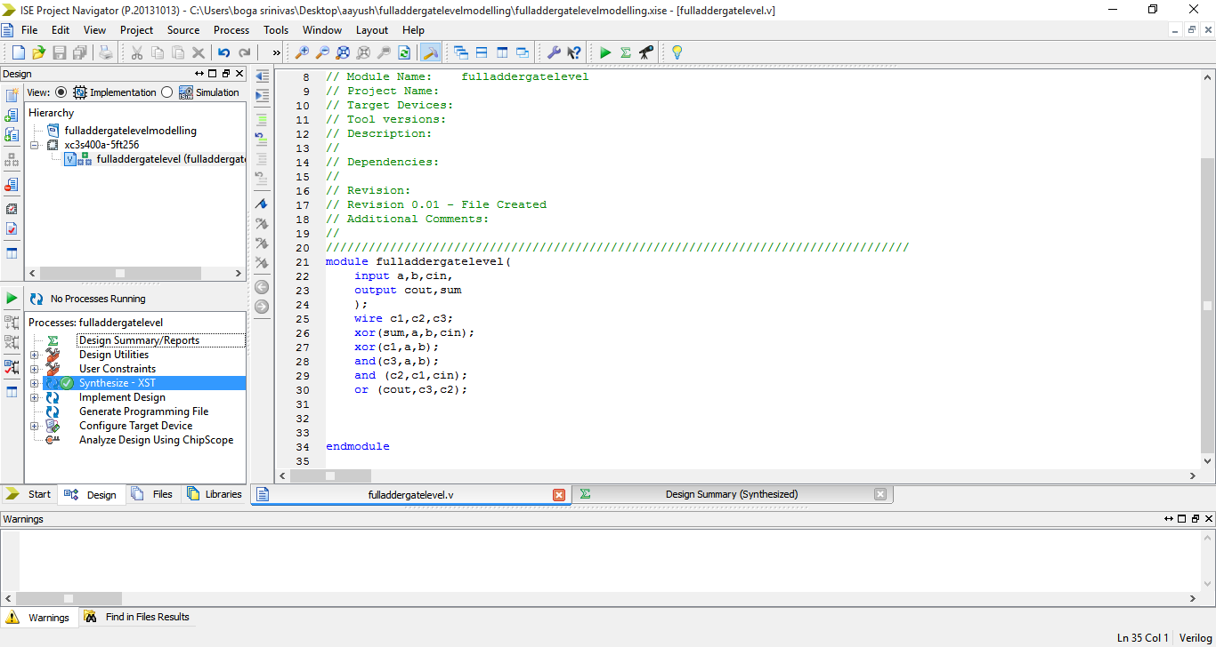

**NETS**

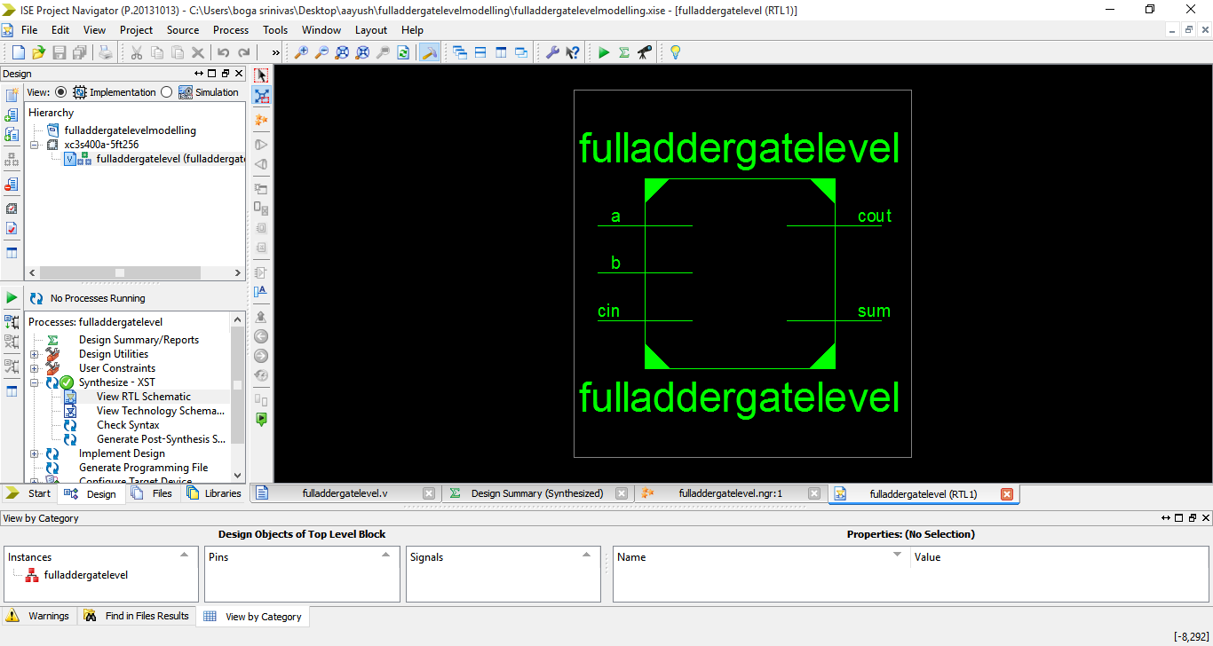

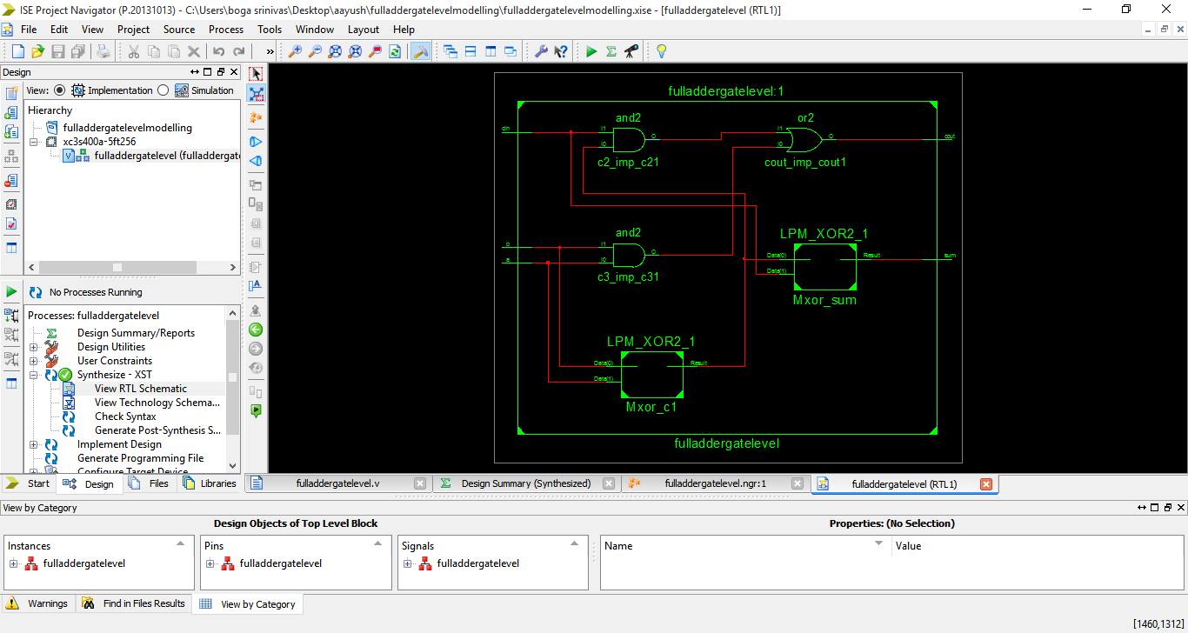

**STIMULUS**

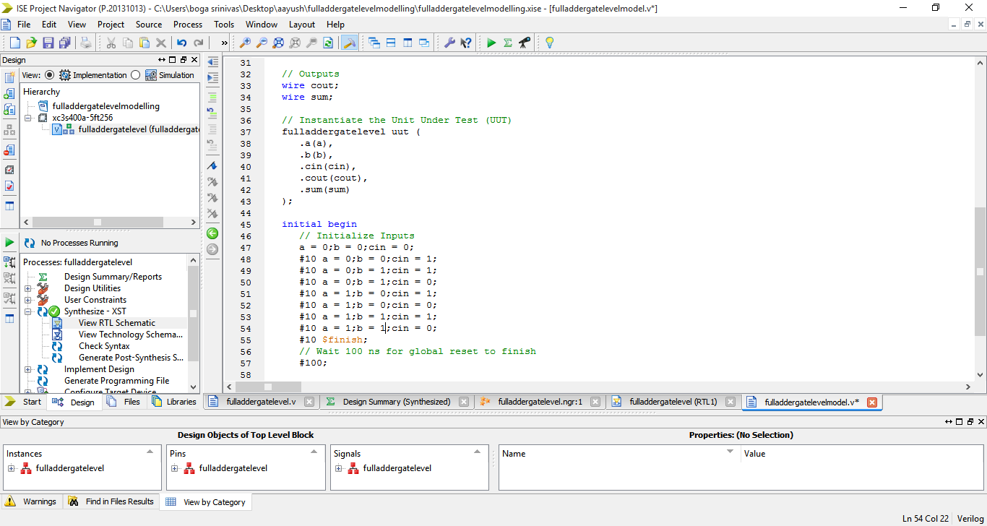

**WAVE FORM**

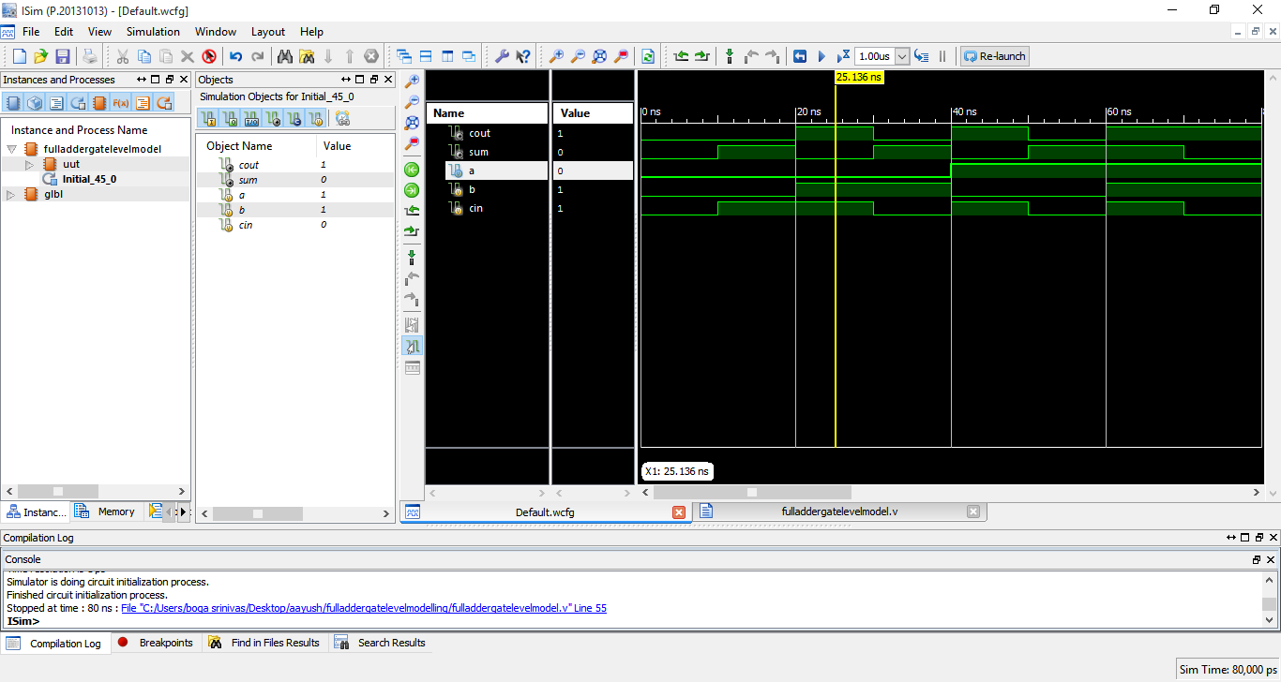

* **DATA FLOW MODEL**

**PROGRAM CODE**

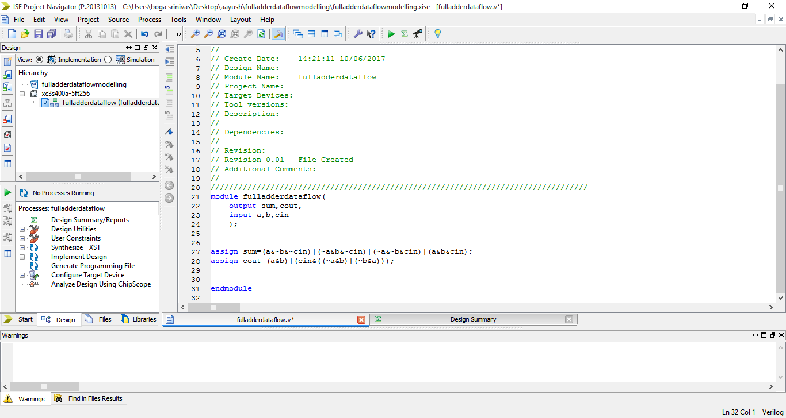

**NETS**

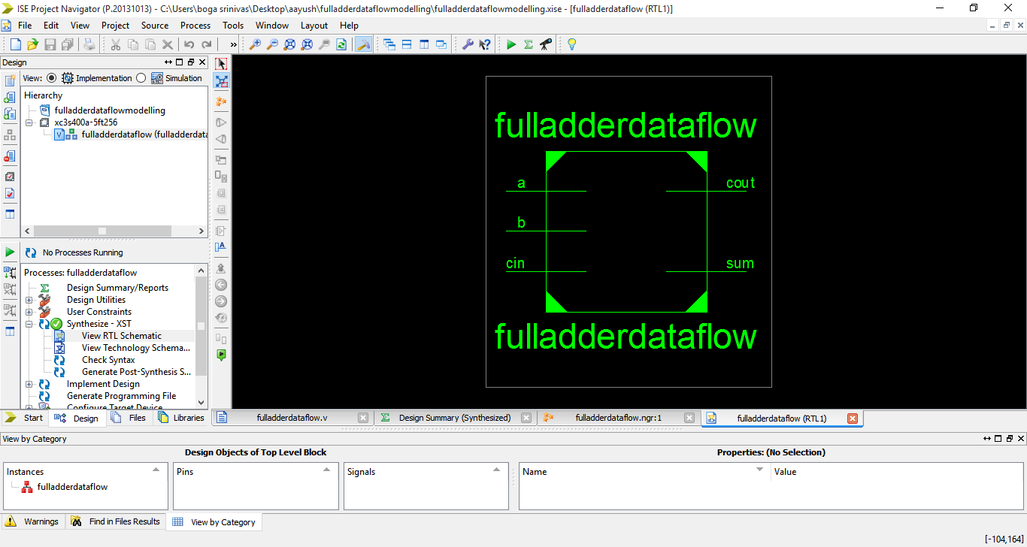

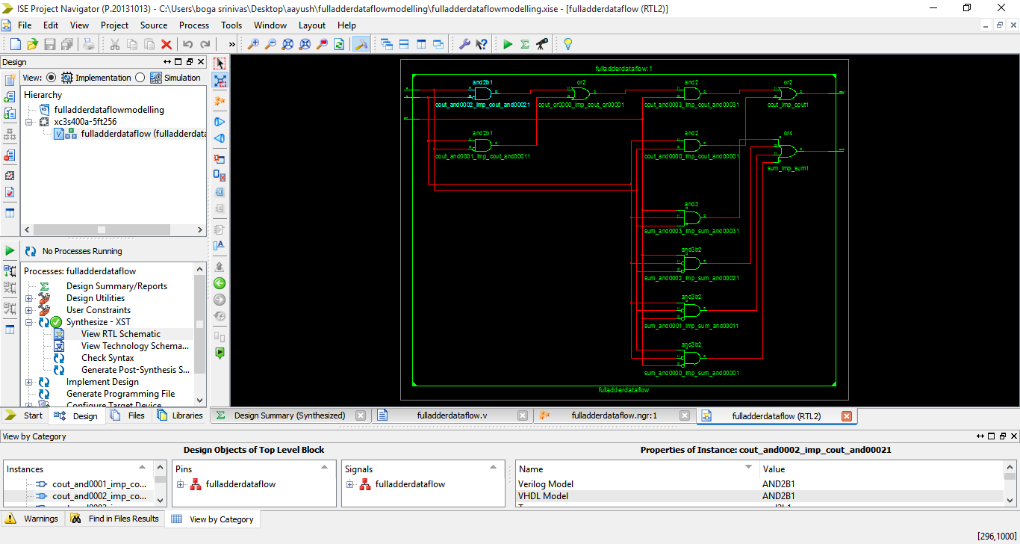

**STIMULUS**

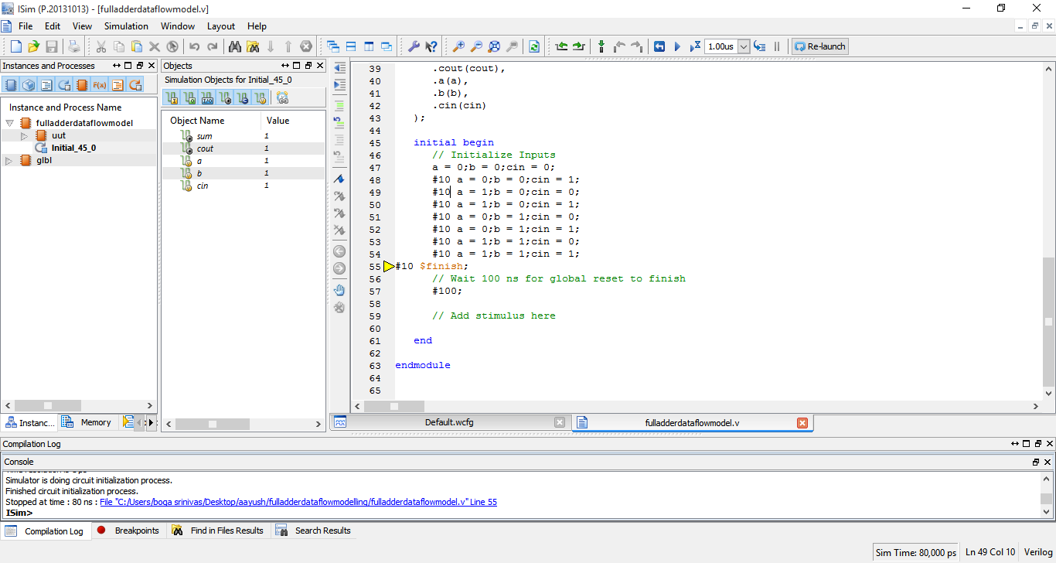 **WAVE FORM**

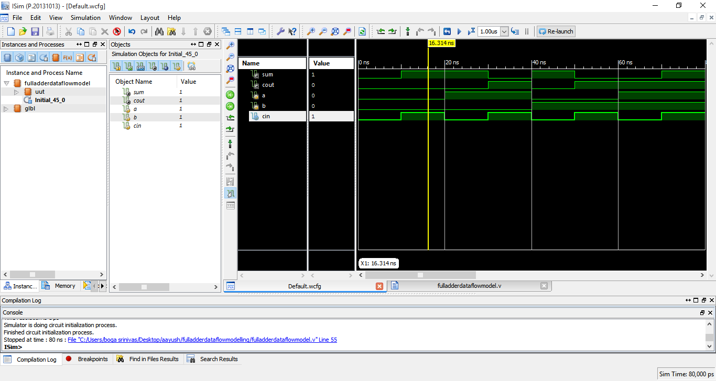

* **BEHAVIOURAL MODEL**

**PROGRAM CODE**

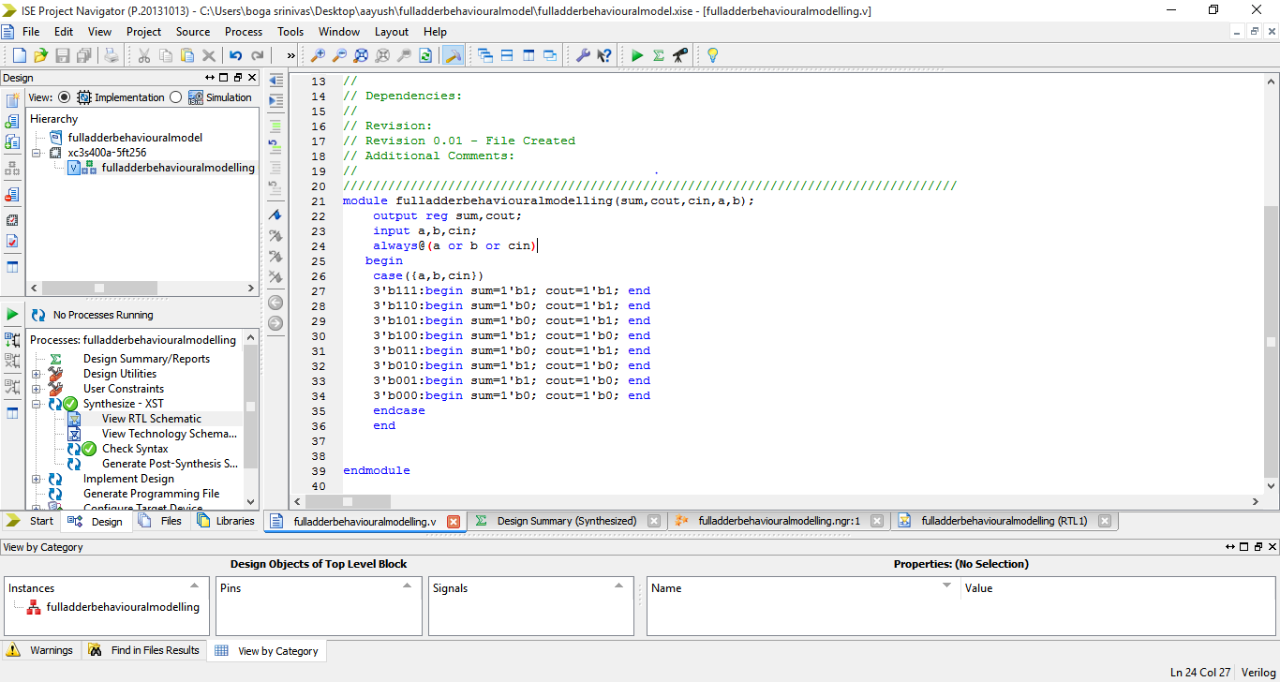

**NETS**

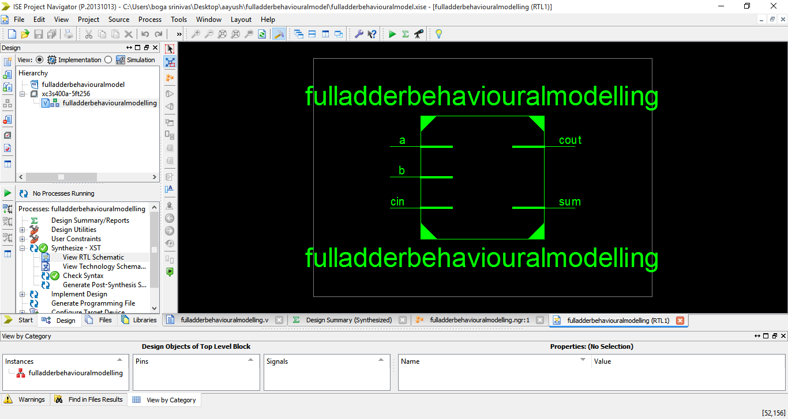

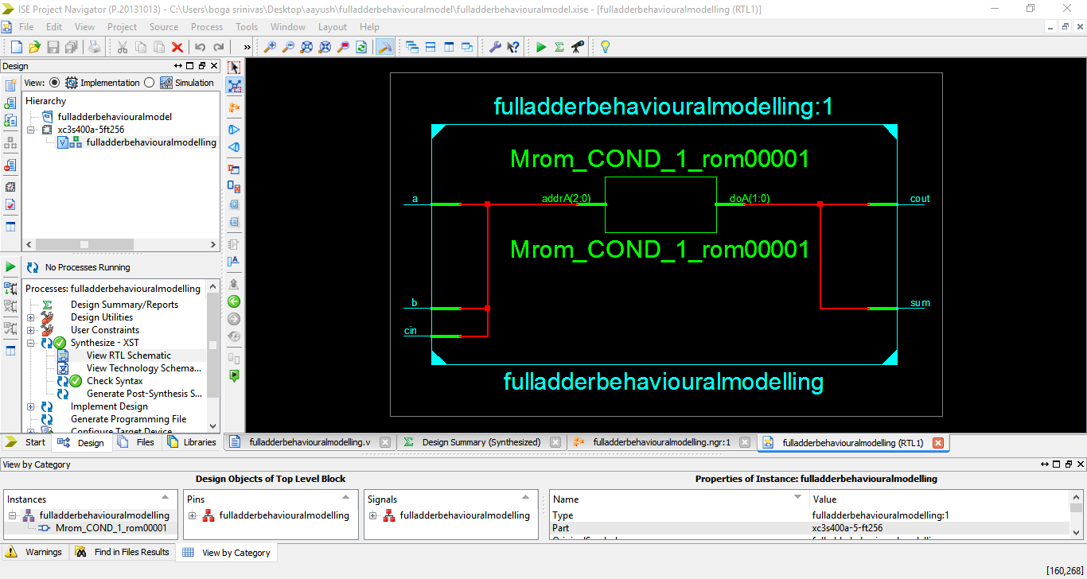

**STIMULUS**

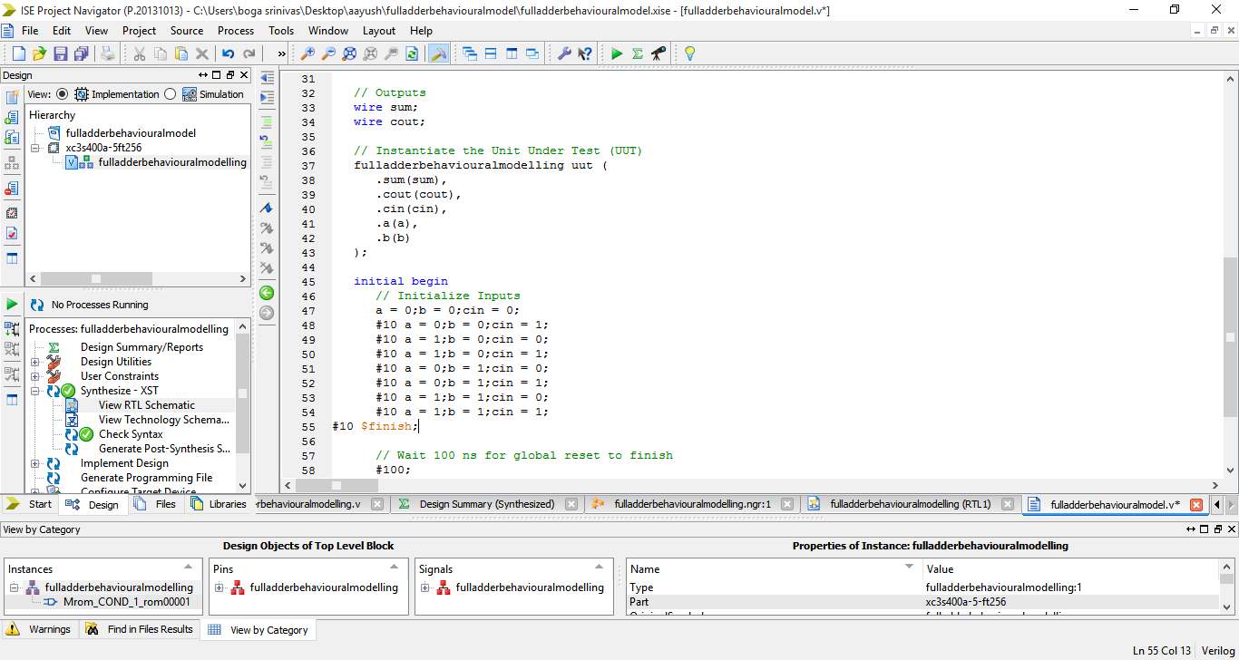

**WAVE FORM**

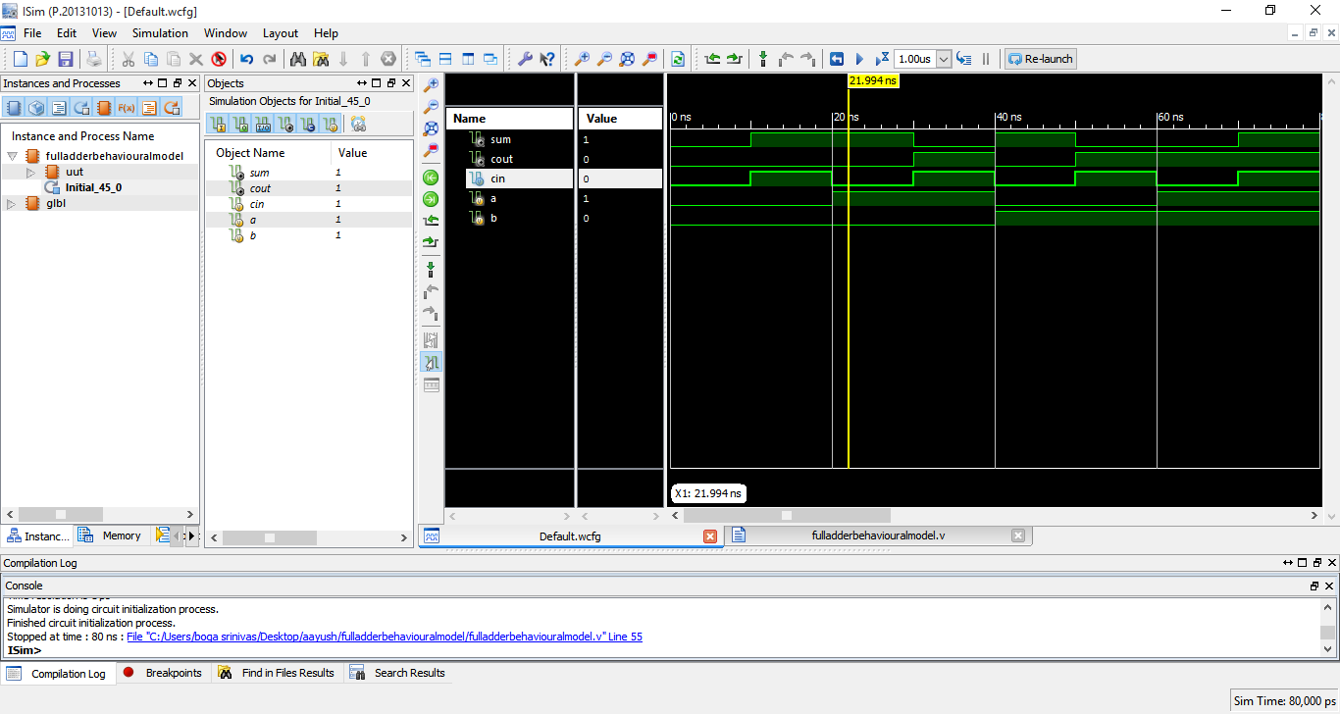

**4 to 1 Multiplexer:-**

A 4 to 1 multiplexer is basically a selector that selects any one of 4 inputs using control switches (S1 and S0) and giving them output

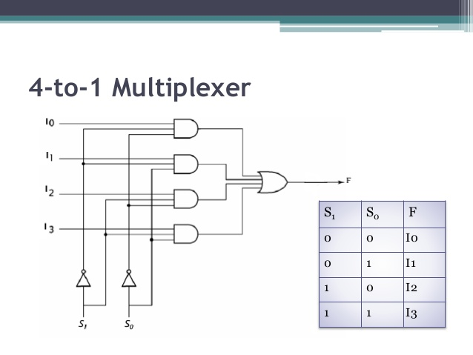

* **GATE LEVEL MODEL**

**PROGRAM CODE**

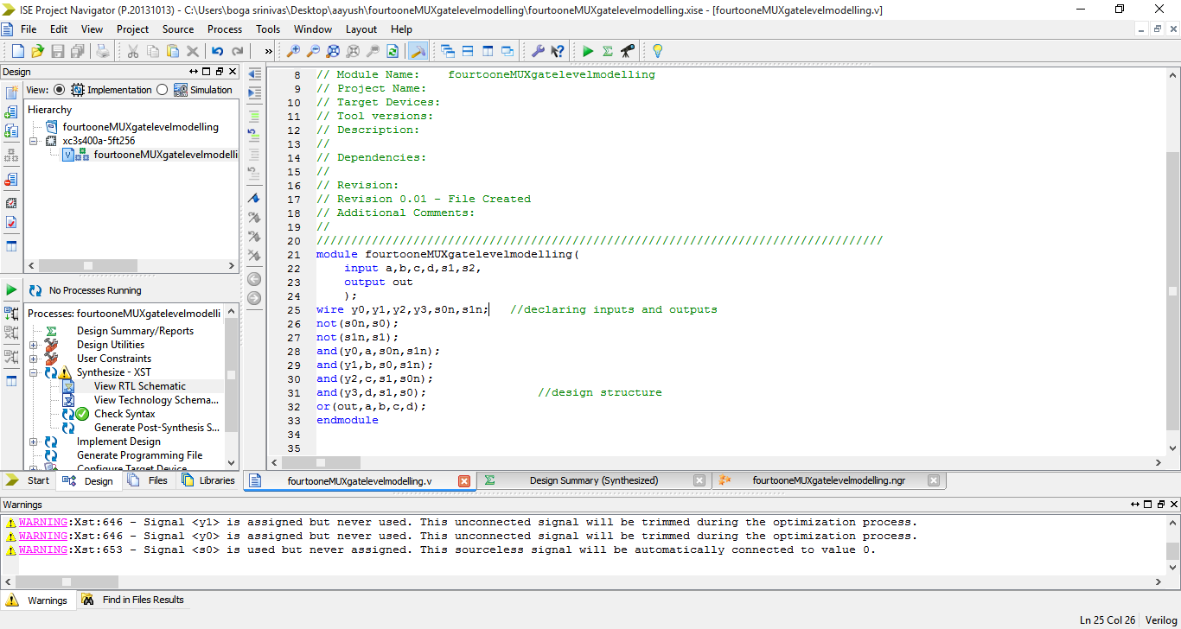

**NETS**

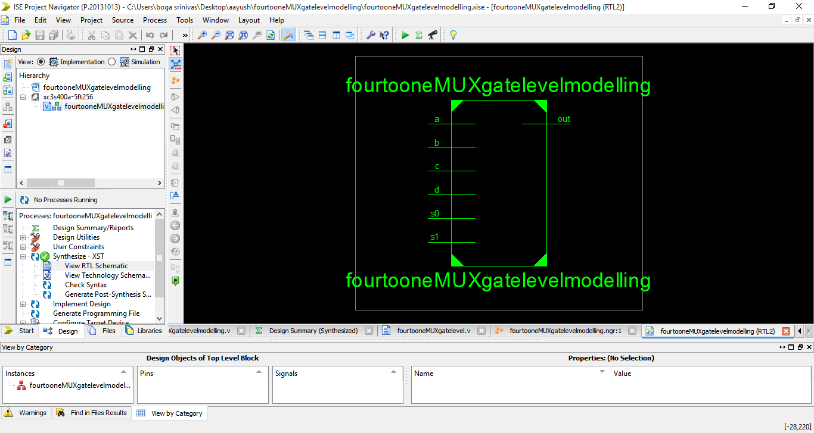

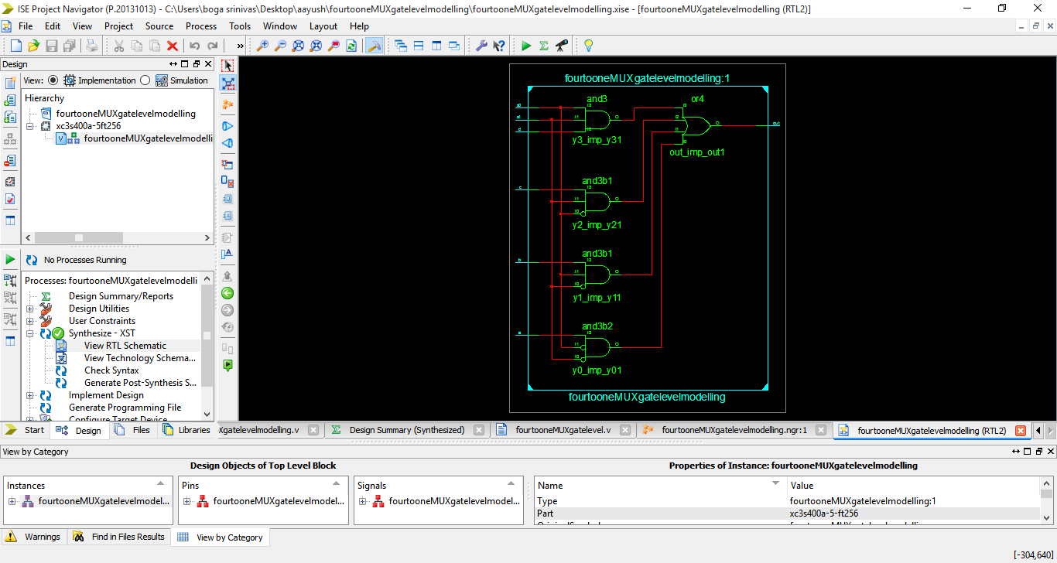

**STIMULUS**

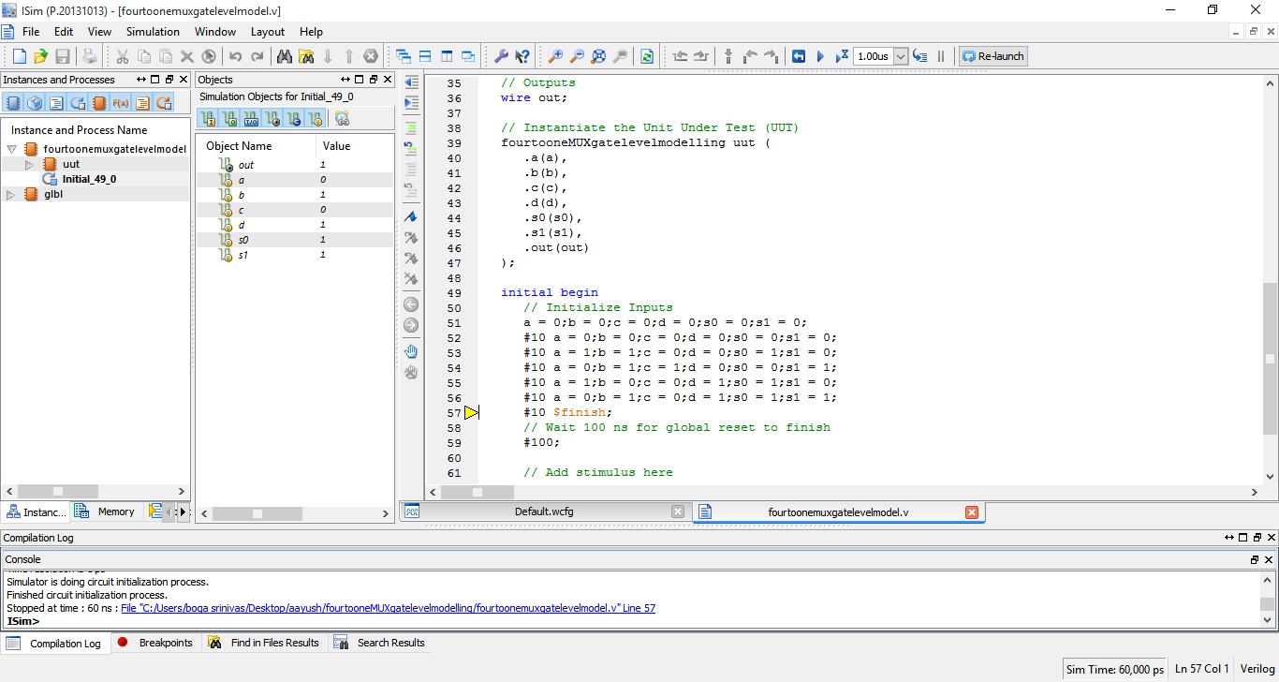

**WAVE FORM**

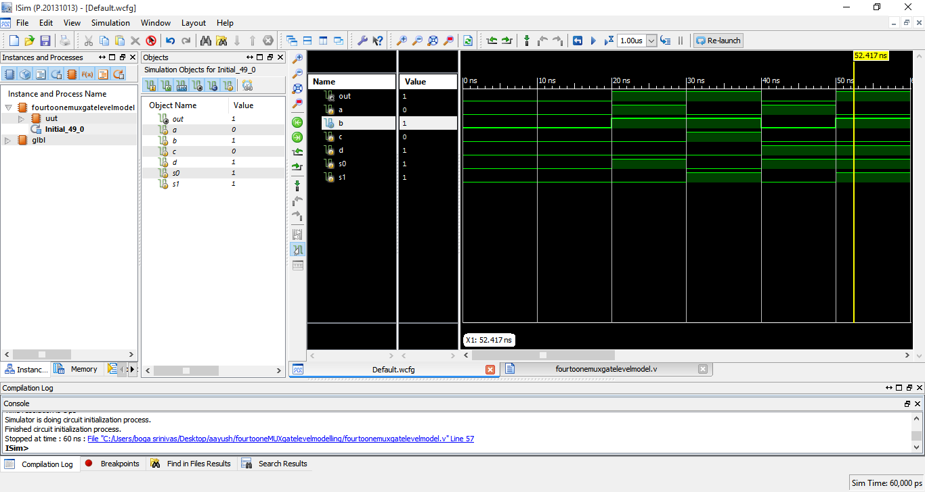

* **DATA FLOW MODEL**

**PROGRAM CODE**

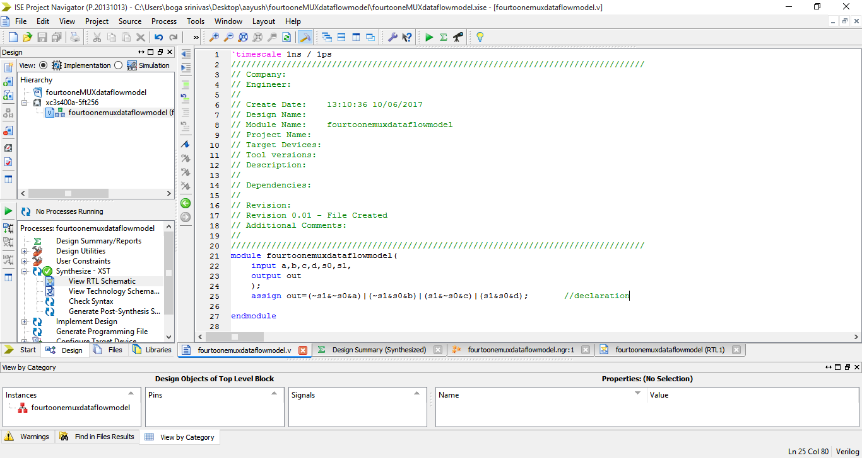

**NETS**

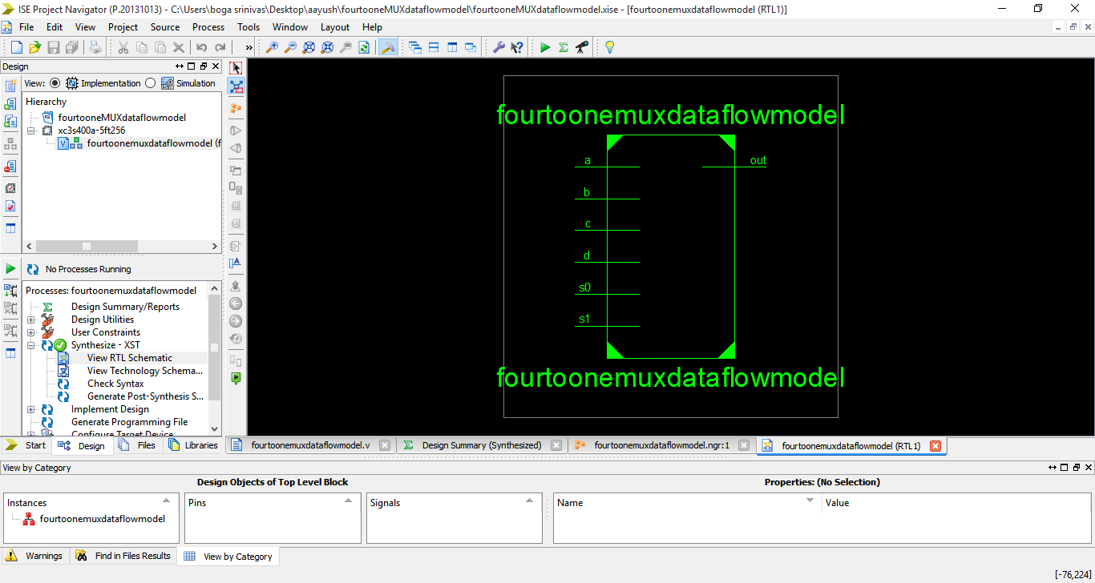

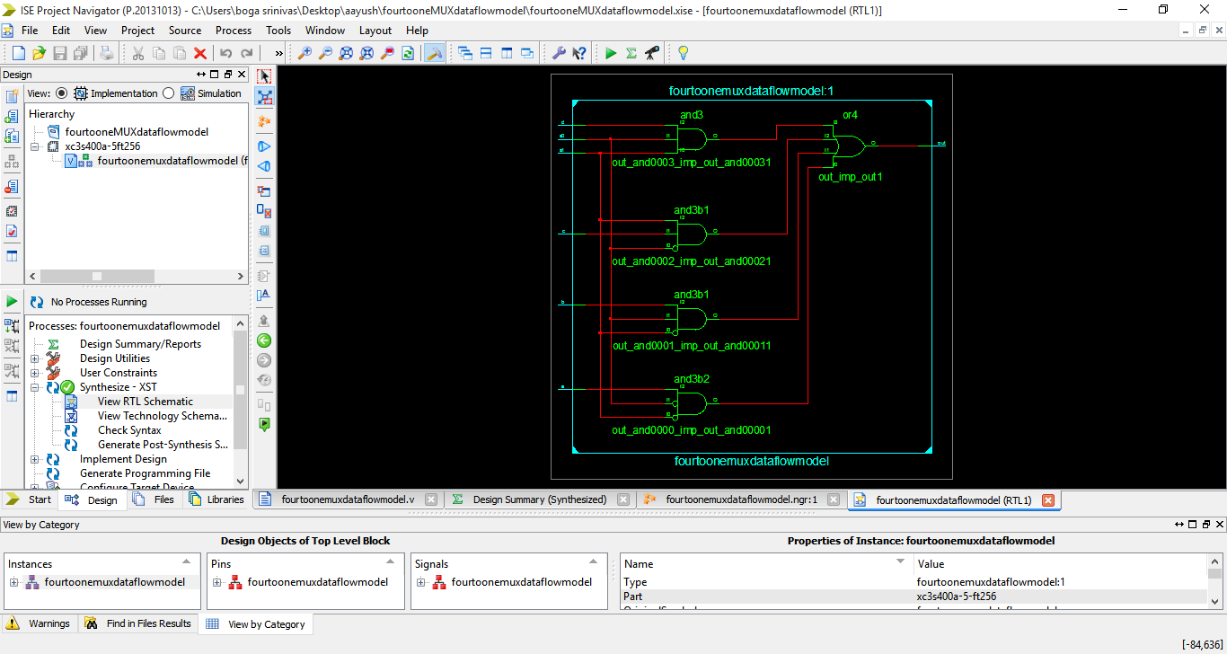

**STIMULUS**

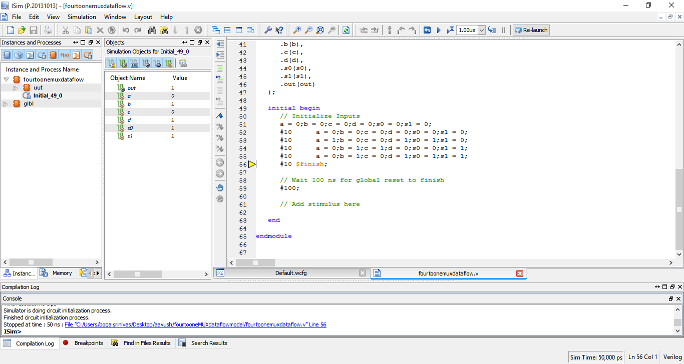

**WAVE FORM**

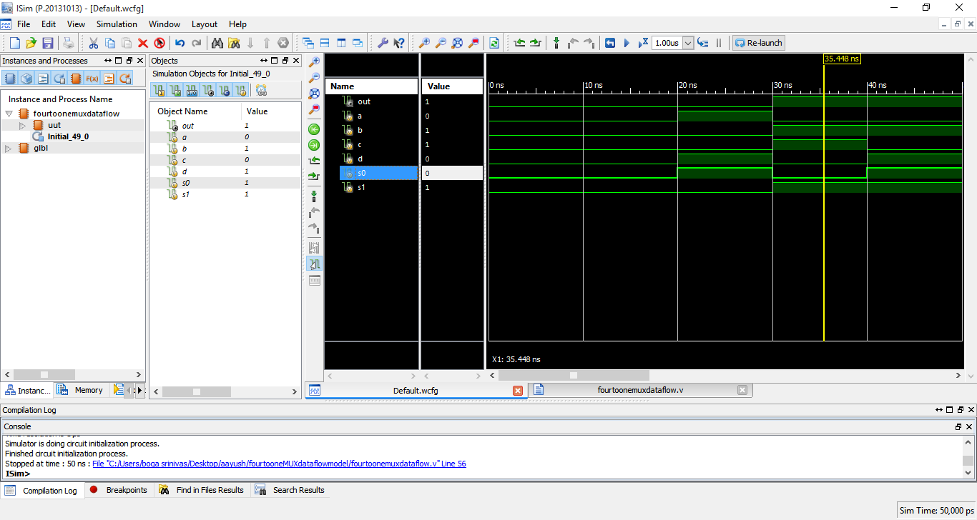

* **BEHAVIOURAL MODEL**

**PROGRAM CODE**

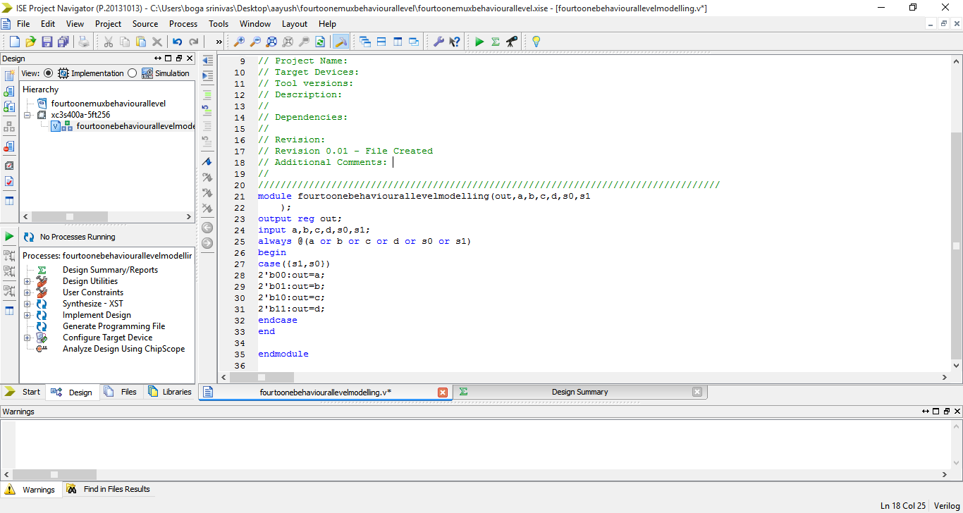

**NETS**

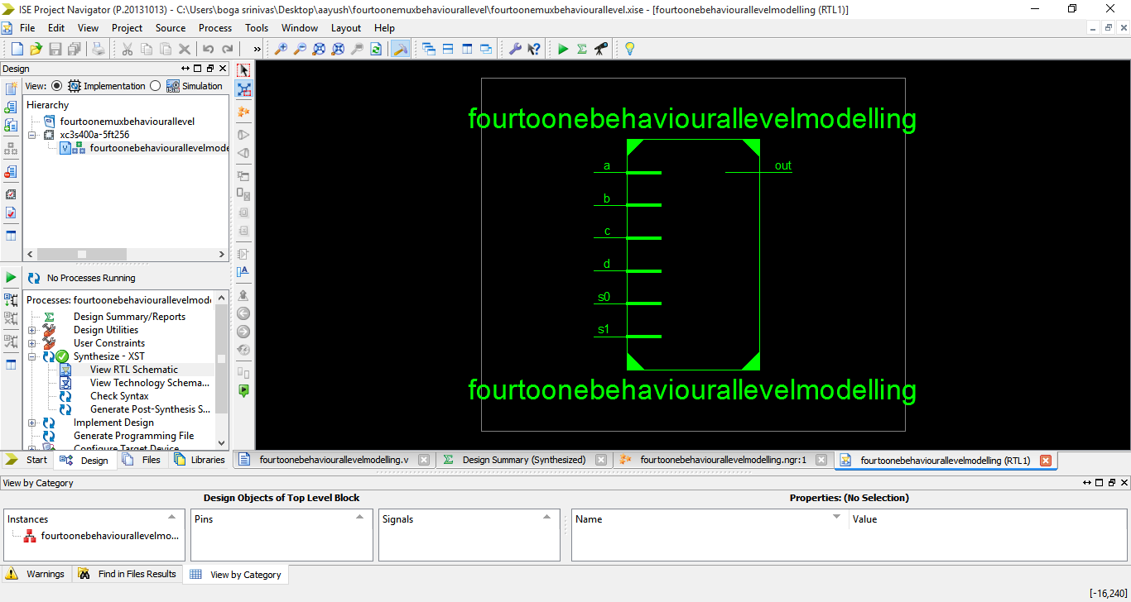

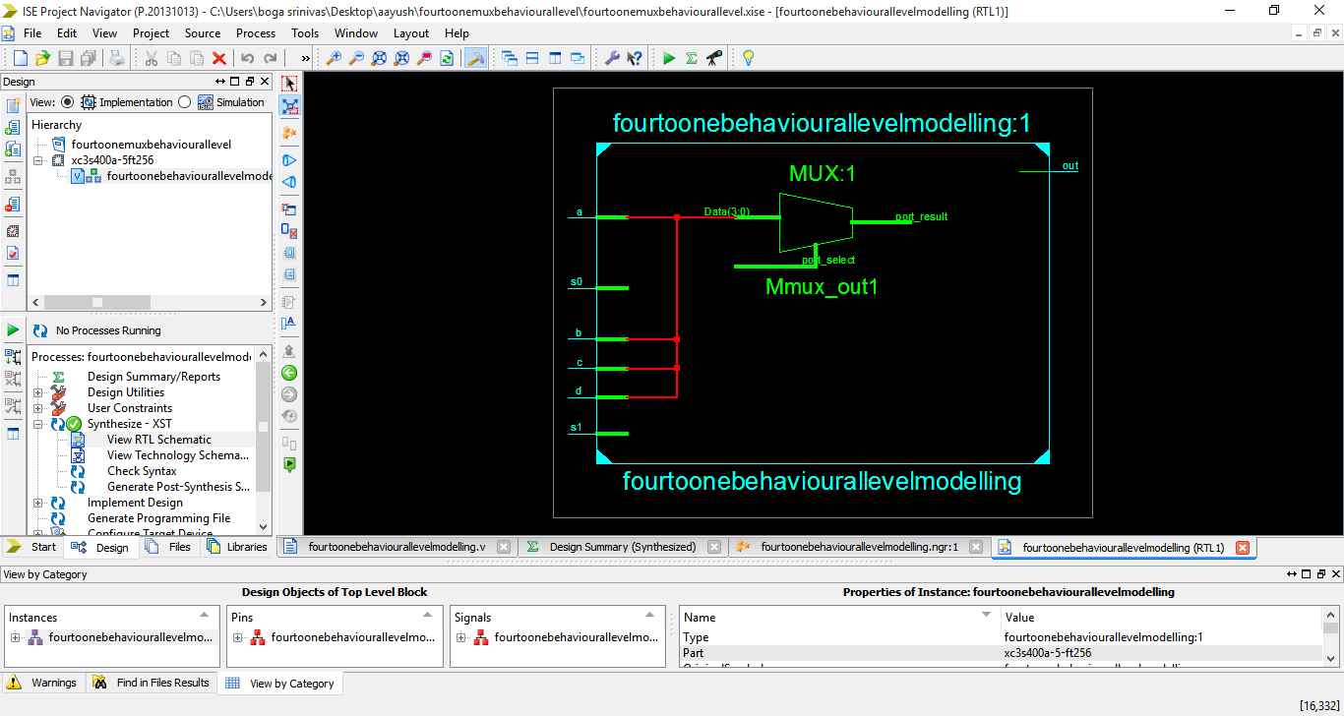

**STIMULUS**



**WAVE FORM**

